***Summary:*** *The non-clinical participant visits involves giving participant information sheet (PIS) to suitable candidates, expand on the information in the PIS and seeking consent. These could be done during patients’ routine visit.*

|  |  |  |
| --- | --- | --- |
| **Date:** | **Time:** | **Location:** |
|  |  |  |

|  |  |  |
| --- | --- | --- |
| **Delegate (s)** | **Location** | **Other comments** |
| 1. Alison Mannion (OT) 2. Rosti Readioff (PDRA) | RJAH |  |

**Task 1**: Explaining the project and giving PIS to suitable candidate (30 min)

**Task 2**: Seeking consent (10 min)

***Summary:*** *The first visit will involve manual muscle testing, biomechanical measurements including arm muscle response to electrical stimulations. In the first visit, they will also have the COPM outcome measure explained to them and be encouraged to start thinking about their functional goals.*

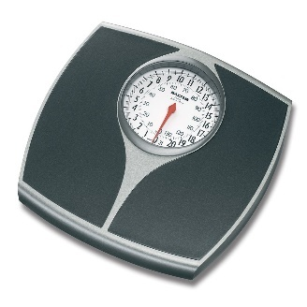

*1 of 6. Scale*

1. Mass of the participant (kg):

----------------------------------------------------END OF 1 of 6. Scale -------------------------------------------

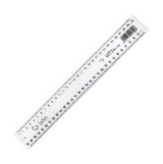

*2 of 6. Tape measure/ Calliper*

|  |  |  |  |  |
| --- | --- | --- | --- | --- |
| **✓** | **No.** | **Parameter** | **Value (mm)** | **Notes** |
|  |  | Height of the participant |  |  |
|  |  | IJ to PX (scaling thorax): |  |  |
|  |  | IJ to C7 (scaling thorax) |  | use calliper |
|  |  | C7 to T8 (scaling thorax) |  | use calliper |
|  |  | GH to EM (scaling humerus) |  |  |
|  |  | GH to EL (scaling humerus) |  |  |
|  |  | EL to US (scaling ulna) |  |  |
|  |  | TS to AA (scaling scapula) |  |  |
|  |  | AI to TS (scaling scapula) |  |  |
|  |  | SC to AC (scaling clavicula) |  |  |
|  |  | EM to RS (scaling radius) |  |  |
|  |  | RS to US (mid-wrist) |  | use calliper |
|  |  | EL to EM (mid-elbow) |  | use calliper |

----------------------------------------------------END OF 2 of 6. Ruler/ tape measure -------------------------------------------

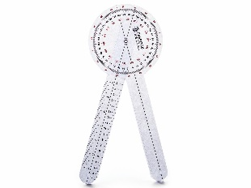

*3 of 6. Goniometer*

**Shoulder**

|  |  |  |  |  |  |
| --- | --- | --- | --- | --- | --- |
| **✓** | **No.** | **Passive ROM** | **Range** | **Participant’s ROM (**°**)** | **Notes** |
|  |  | **Flexion** | 0° – 110° or 180° with pectoral gridle |  |  |
|  |  | **Extension** | 0° – 70° or 90° with pectoral gridle |  |  |
|  |  | **Abduction** | 0° – 120° or 180° with pectoral gridle |  |  |
|  |  | **Adduction** | 0° – 35° |  |  |
|  |  | **Medial Rotation** | 0° – 90° |  |  |
|  |  | **Lateral Rotation** | 0° – 80° |  |  |

**Elbow**

|  |  |  |  |  |  |
| --- | --- | --- | --- | --- | --- |
| **✓** | **No.** | **Passive ROM** | **Range** | **Participant’s ROM (**°**)** | **Notes** |
|  |  | **Flexion** | 0° – 160° or 145° for active ROM |  |  |
|  |  | **Extension** | 0° |  |  |

**Wrist**

|  |  |  |  |  |  |
| --- | --- | --- | --- | --- | --- |
| **✓** | **No.** | **Passive ROM** | **Range** | **Participant’s ROM (**°**)** | **Notes** |
|  |  | **Flexion** | 0° – 85° |  |  |
|  |  | **Extension** | 0° – 85° |  |  |
|  |  | **Abduction (radial deviation)** | 0° – 15° |  |  |
|  |  | **Adduction (ulnar deviation)** | 0° – 45° |  |  |
|  |  | **Pronation** | 0° – 85° |  |  |
|  |  | **Supination** | 0° – 85° |  |  |

----------------------------------------------------------------------------------------END OF 3 of 6. Goniometer -----------------------------------------------------------------------------------------------------

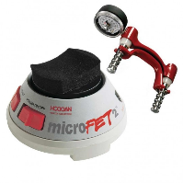

*4 of 6. Dynamometer*

***Note****: In order to eliminate gravity when taking measurements, participant must be either in supine position or an anti-gravity arm support needs to be used if possible.* <https://www.youtube.com/watch?v=8G2x1VYsFGU> (the first 5 minutes)

**Shoulder** (for gravity eliminated forces - supine position for SCI participants might not be possible! )

|  |  |  |  |  |  |  |
| --- | --- | --- | --- | --- | --- | --- |
| **✓** | **No.** | **Active ROM** | **Range (N)** | **Dynamometer Position (mm)** | **Participant’s Force (N)** | **Notes** |
|  |  | **Flexion** |  |  |  |  |
|  |  | **Extension** |  |  |  |  |
|  |  | **Abduction** |  |  |  |  |
|  |  | **Adduction** |  |  |  |  |
|  |  | **Medial Rotation** |  |  |  |  |
|  |  | **Lateral Rotation** |  |  |  |  |

**Elbow** (Use anti-gravity arm support)

|  |  |  |  |  |  |  |
| --- | --- | --- | --- | --- | --- | --- |
| **✓** | **No.** | **Active ROM** | **Range (N)** | **Dynamometer Position (mm)** | **Participant’s Force (N)** | **Notes** |
|  |  | **Flexion** |  |  |  |  |
|  |  | **Extension** |  |  |  |  |

**Wrist**

|  |  |  |  |  |  |  |
| --- | --- | --- | --- | --- | --- | --- |
| **✓** | **No.** | **Active ROM** | **Range (N)** | **Dynamometer Position (mm)** | **Participant’s Force (N)** | **Notes** |
|  |  | **Flexion** |  |  |  |  |
|  |  | **Extension** |  |  |  |  |

**Fingers**

1. Grip strength:

----------------------------------------------------END OF 4 of 6. Dynamometer-------------------------------------------

*5 of 6. Stimulator and Dynamometer*

**Shoulder**

|  |  |  |  |  |  |  |  |  |
| --- | --- | --- | --- | --- | --- | --- | --- | --- |
| **✓** | **No.** |  | **Flexion** | **Extension** | **Abduction** | **Adduction** | **Medial Rotation** | **Lateral Rotation** |
| **-** |  | **Primary Muscles (root value of nerve supply)** | 1. Pectoralis major (C5, C6, C7, C8, T1) 2. Deltoid (anterior fibres) (C5, C6) 3. Biceps brachii (long head) (C5, C6) 4. Coracobrachialis (C6, C7) | 1. Latissimus dorsi (C6, C7, C8) 2. Teres major (C6, C7) 3. Pectoralis major (to midline) (C5, C6, C7, C8, T1) 4. Deltoid (posterior fibres) (C5, C6) 5. Triceps (long head) (C6, C7, C8) | 1. Supraspinatus (C5, C6) 2. Deltoid (C5, C6) | 1. Coracobrachialis (C6, C7) 2. Pectoralis major (C5, C6, C7, C8, T1) 3. Latissimus dorsi (C6, C7, C8) 4. Teres major (C6, C7) | 1. Subscapularis (C5, C6, C7) 2. Teres major (C6, C7) 3. Latissimus dorsi (C6, C7, C8) 4. Pectoralis major (C5, C6, C7, C8, T1) 5. Deltoid (anterior fibres) (C5, C6) | 1. Teres minor (C5, C6) 2. Infraspinatus (C5, C6) 3. Deltoid (posterior fibres) (C5, C6) |
|  |  | **Paralysed Muscles** |  |  |  |  |  |  |

|  |  |  |  |  |  |
| --- | --- | --- | --- | --- | --- |
| **✓** | **No.** | **ROM** | **Dynamometer Position (mm)** | **Participant’s Force (N)** | **Notes** |
|  |  | **Flexion** |  |  |  |
|  |  | **Extension** |  |  |  |
|  |  | **Abduction** |  |  |  |
|  |  | **Adduction** |  |  |  |
|  |  | **Medial Rotation** |  |  |  |
|  |  | **Lateral Rotation** |  |  |  |

**Elbow**

|  |  |  |  |  |
| --- | --- | --- | --- | --- |
| **✓** | **No.** |  | **Flexion** | **Extension** |
| **-** |  | **Primary Muscles (root value of nerve supply)** | 1. Biceps bacchii (C5, C6) 2. Brachialis (C5, C6) 3. Brachioradialis (C5, C6) 4. Pronator teres (C6, C7) | 1. Triceps brachii (C6, C7, C8) 2. Anconeus (C7, C8) |
|  |  | **Paralysed Muscles** |  |  |

|  |  |  |  |  |  |
| --- | --- | --- | --- | --- | --- |
| **✓** | **No.** | **ROM** | **Dynamometer Position (mm)** | **Participant’s Force (N)** | **Notes** |
|  |  | **Flexion** |  |  |  |
|  |  | **Extension** |  |  |  |

**Wrist**

|  |  |  |  |  |  |  |  |  |
| --- | --- | --- | --- | --- | --- | --- | --- | --- |
| **✓** | **No.** |  | **Pronation** | **Supination** | **Flexion** | **Extension** | **Abduction (radial deviation)** | **Adduction (ulnar deviation)** |
| **-** |  | **Primary Muscles (root value of nerve supply)** | 1. Pronators teres (C6, C7) 2. Pronator quadratus (C8, T1) 3. Brachioradialis (C5, C6) | 1. Supinator (C5, C6) 2. Biceps brachii (C5, C6) 3. Brachioradialis (C5, C6) | 1. Flexor carpi ulnaris (C7, C8) 2. Flexor carpi radialis (C6, C7) 3. Palmaris longus (C8) | 1. Extensor carpi ulnaris (C7, C8) 2. Extensor carpi radialis longus (C6, C7) 3. Extensor carpi radialis brevis (C6, C7) | 1. Flexor carpi radialis (C6, C7) 2. Extensor carpi radialis longus (C6, C7) 3. Extensor carpi radialis brevis (C6, C7) | 1. Flexor carpi ulnaris (C7, C8) 2. Extensor carpi ulnaris (C7, C8) |
|  |  | **Paralysed Muscles** |  |  |  |  |  |  |

|  |  |  |  |  |  |
| --- | --- | --- | --- | --- | --- |
| **✓** | **No.** | **ROM** | **Dynamometer Position (mm)** | **Participant’s Force (N)** | **Notes** |
|  |  | **Flexion** |  |  |  |
|  |  | **Extension** |  |  |  |

1. Grip strength:

----------------------------------------------------END OF 5 of 6. Stimulator and Dynamometer -------------------------------------------

*6 of 6. COPM outcome measure*

1. Explaining COPM outcome measure

----------------------------------------------------END OF 6 of 6. COPM outcome measure -------------------------------------------

********************************** END OF FIRST VISIT **********************************

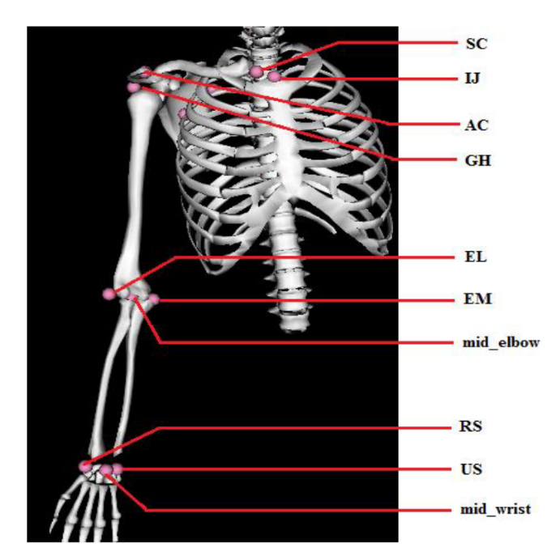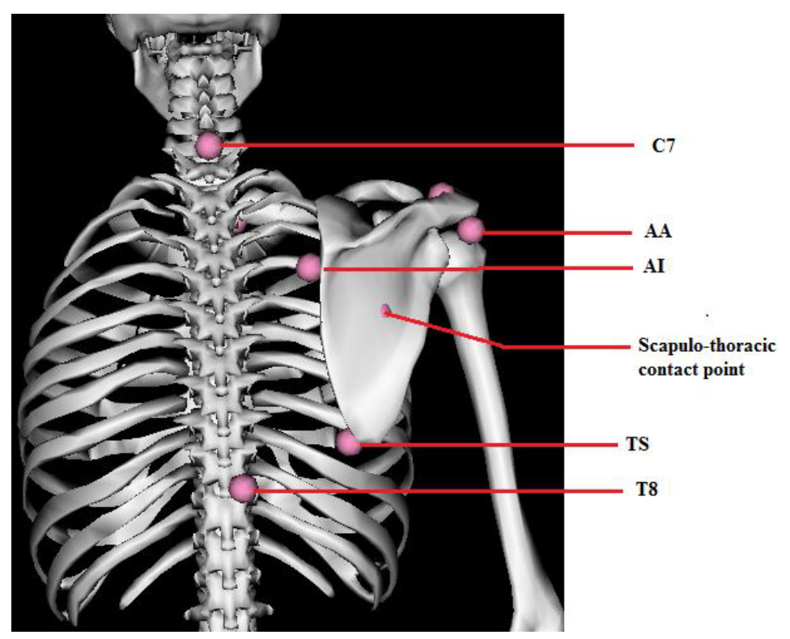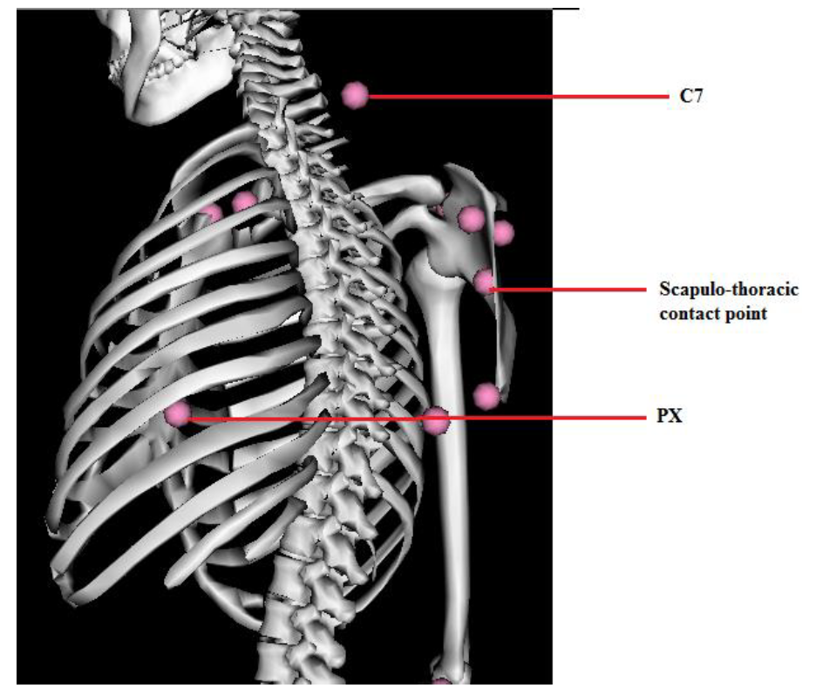

|  |  |  |  |  |  |
| --- | --- | --- | --- | --- | --- |
| **Thorax** | **Humerus** | **Ulna** | **Radius** | **Clavicle** | **Scapula** |
| **IJ**: Incisura Jugularis (suprasternal notch)  **PX**: Processus Xiphoideus (most caudal point on sternum)  **C7**: Processus Spinosus of 7th Cervical vertebra  **T8**: Processus Spinosus of 8th cervical vertebra | **GH**: Glenohumeral rotation centre, estimated by regression  **EM**: Most caudal point on Medial Epicondyle  **EL**: Most caudal point on Lateral Epicondyle | **EL**: Most caudal point on Lateral Epicondyle  **US**: Ulnar Styloid | **EM**: Most caudal point on Medial Epicondyle  **EL**: Most caudal point on Lateral Epicondyle | **SC**: Most ventral point on Sternoclavicular joint  **AC**: Most dorsal point on Acromioclavicular joint | **AC**: most dorsal point on Acromioclavicular joint  **TS**: Trigonum Spinae, point on medial border in line with the scapular spine  **AI**: Angulus Inferior, most caudal point of scapula  **AA**: Angulus Acromialis, most latero-dorsal point of scapula  **PC**: Most ventral point of processus coracoideus |

|  |  |
| --- | --- |
|  |  |

*Note: Clinical movement of the shoulder joint is with respect to the cardinal planes of the body. These movements of the shoulder are usually combinations (i.e. ‘abduction’ = abduction + extension).*

|  |
| --- |
| **Elbow flexion & extension** |

**Wrist ROM**

|  |  |
| --- | --- |
|  |  |

***Summary:*** *The second visit will involve quantifying the movement achieved under fixed-pattern stimulation to assess repeatability, speed, smoothness, range of movement and grip strength. They will also discuss their functional goals with a therapist and complete the COPM questionnaire. The second visit will also involve testing the model-based controller where movement is initiated and controlled by the user. Recording of performance will be made at this visit and used to refine the controllers offline. This visit may need to be repeated an additional two times for further controller refinement and testing.*

***Summary:*** *The final visit will assess their ability in performing a standard set of movement tasks, as well as benchmarking their achievement of their goals as set out using the COPM.*

Each of the assessments described below is used routinely in clinical movement analysis.

Clinical and biomechanical exam

This will include manual muscle testing of arm muscles, testing arm muscles for response to stimulation, strength of arm muscles, quantifying range of motion of the upper limb joints, assessment of spasticity or stiffness in the upper limb, and anthropometry (measurement of limb dimensions).

Dynamometer

This medical instrument which is frequently used by physiotherapists and other clinicians will be utilised in this study to measure hand strength of patients. This will also be used to quantify strength achieved when using FES system.

Surface electromyography (EMG)

Subjects participating in surface EMG recording will have the muscle bellies identified by palpation and marked during the clinical examination. Skin preparation is sometimes required, using a conductive and slightly abrasive gel. Subjects with lots of body hair may need to have small patches of skin shaved at the site of the sensors. Small sensors are placed on the skin over each muscle belly. These are held in place using a combination of double-sided tape and elasticated bandage.

Movement analysis

Movement analysis makes use of goniometers (devices to measure joint angles), or reflective markers and cameras to record body movements. Markers (frequently used in gait laboratories) are attached to the skin over key anatomical landmarks (located during the clinical examination) by means of double-sided tape supplied for this purpose. Special infrared cameras in the gait laboratory are used to track the position of these markers in three dimensions. This is then used to record the movements of the participant’s arms and body. From these recordings, the quality and quantity of movement can be evaluated.